Max Engels, Kade Pruitt, Coleman Beggs

Richard Waer

ENGR 216-502

24 October 2019

Lab 4 Write up: Friction

The purpose of this lab was to find the kinetic and static friction for two different surfaces. We used a self-drawn diagram of the apparatus to help us place values easier. Using this diagram we were able to make a free body diagram to determine our forces to find the kinetic friction. To find static friction we just took the tangent of the angle with respect to ‘x’. To find the kinetic friction we used used the work energy theorem with the limits being the length of the hypotenuse of the apparatus. After we found the limits we used our free body diagrams to find our sum of forces equation and set it equal to the change in kinetic energy. After simplifying and integrating we found the value for friction for the rubber side and wood side.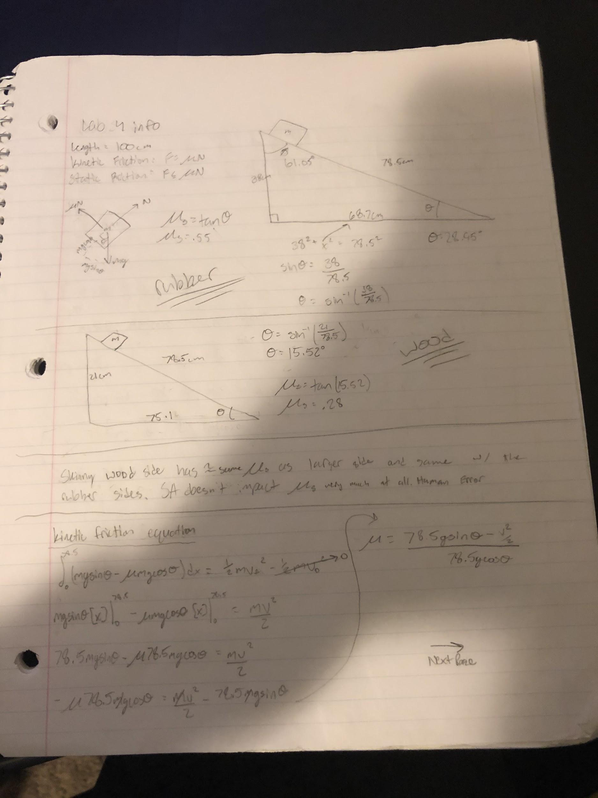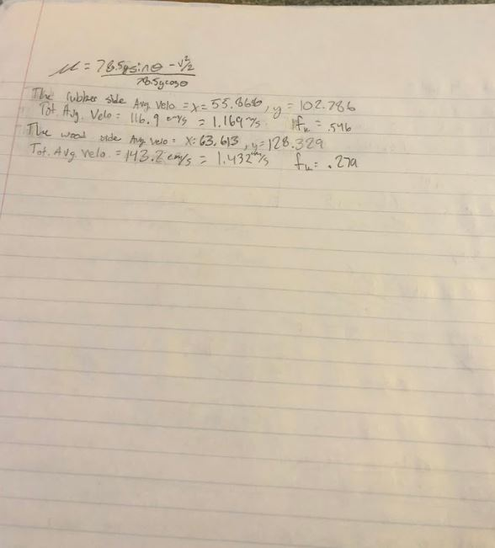

Our experiments were done by first setting up the wood apparatus to find static friction by raising the wooden ramp to find the angle at which the wood piece would start to slide down. We then did several trials for the wood and rubber side while taking a video using example 6. This gave us enough data to find an average for all values that we could use to find our friction values.

One of the objectives was to determine if surface area impacted the friction value. We determined that surface area had no impact on the friction force. The estimated values we got for the static friction of the rubber side and the wooden side were .55 and .28 respectively. For the kinetic friction values for the rubber side and wood side were similar as the equations yielded .546 and .279 respectively.

The calculated confidence interval for the kinetic friction of the rubber side of the block was 0.5446666666666667 <= x <= 0.5473333333333333. This was done using the following python code:

FricRubber = [0.546, 0.543, 0.549, 0.544, 0.548, 0.540, 0.551, 0.542, 0.551]

avgFricRubber = 0

for i in FricRubber:

avgFricRubber += i

avgFricRubber /= len(FricRubber)

stdFricRubber = stats.stdev(FricRubber)

z = 1.96

Confidence = avgFricRubber - stdFricRubber/math.sqrt(len(FricRubber))

Confidence1 = avgFricRubber + stdFricRubber/math.sqrt(len(FricRubber))

In the above code, 0.5446666666666667 was the value of the variable named “Confidence”, and 0.5473333333333333 was the value of the variable named “Confidence1”.